Lab Report No 8 AND 9

Z-TRANSFORM
Digital Signal Processing



Submitted By:
[Huzaifa Shahbaz]
[21-CE-009]

Submitted to:
Engr. Hareem Khan
Dated:
3rdMay,2024

Department of Computer Engineering,

HITEC University, Taxila
Lab Example No 1:

Solution:
Brief description (3-5 lines)
Poles, zeros and ROC of the expression of following form can determine using tf2zp command. Consider response of an LTI system. G(z)=2z⁴+16z³+44z²+56z+32/3z⁴+3z³-15z²18z-12
The code
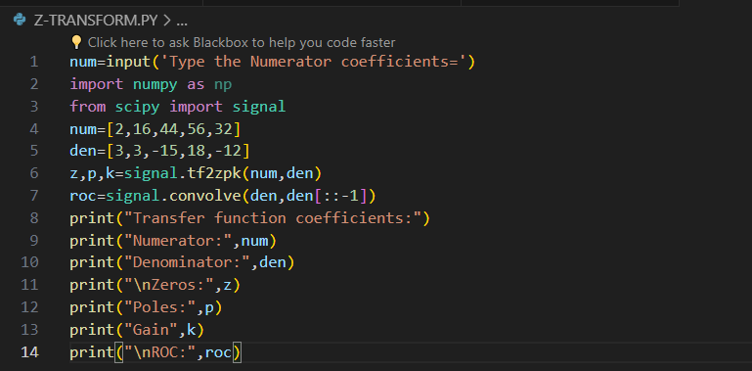
The results (Screenshot)
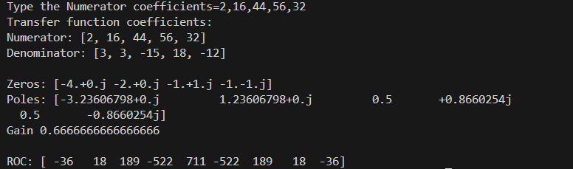

Lab Task No 1(i):

Solution:
Brief description (3-5 lines)
P-1) Consider the following difference equations: Obtain the pole zero plot of the given systems, Analyze the above systems for stability, find their Fourier transform if possible. Compute the impulse response of the systems. P-2) Find h[n]: H2(z)=2z⁴+6.4z³+4.9z²-0.1z-0.6/5z⁴+15.5z³+13.7z²-22.52z-0.48
The code
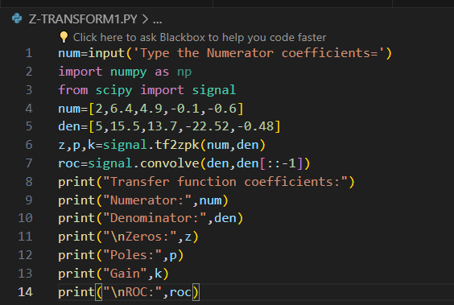
The results (Screenshot)
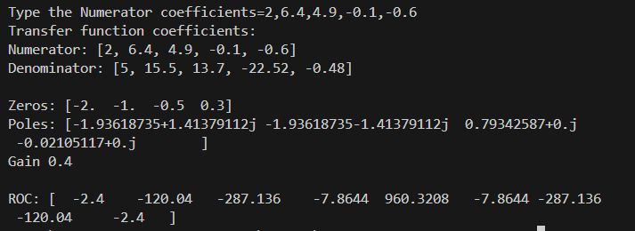
Lab Task No 1(ii):

Solution:
Brief description (3-5 lines)
P-1) Consider the following difference equations: Obtain the pole zero plot of the given systems, Analyze the above systems for stability, find their Fourier transform if possible. Compute the impulse response of the systems. P-2) Find h[n]: H1(z)=(z+0.4) (z-0.91) (z²+0.3z+0.4)/(z²-0.6z+0.6) (z²+3z+5)
The code
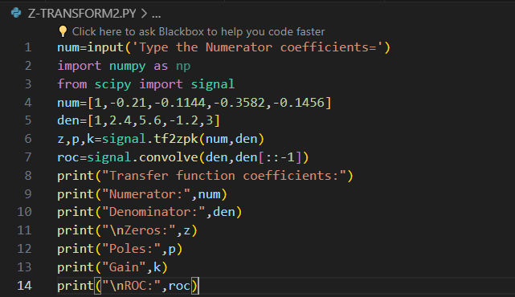
The results (Screenshot)
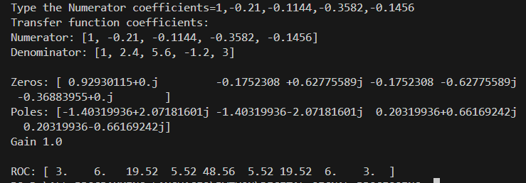
Conclusion
In conclusion, the Z-transform is a valuable tool for analyzing and designing discrete-time systems, providing insights into their behavior and enabling efficient signal processing techniques. Its applications extend across various domains, making it an essential concept in the field of engineering and mathematics.

